Assignment No. 11
- TITLE : Implement a generic program using any collection class to count the number of elements in a collection that have a specific property such as even numbers, odd number, prime number and palindromes.

- CODE:
#include <iostream>
#include <vector>
using namespace std;

bool isPrime(int n) {
if (n <= 1) return false;
for (int i = 2; i * i <= n; i++) {
if (n % i == 0) return false;
}
return true;
}

bool isPalindrome(int n) {
int original = n, rev = 0;
while (n > 0) {
rev = rev * 10 + n % 10;
n /= 10;
}
return original == rev;
}

int main() {
vector<int> v;
int n, val;

cout << "Enter number of elements: ";
cin >> n;

cout << "Enter " << n << " elements: ";
for (int i = 0; i < n; i++) {
cin >> val;
v.push_back(val);
}

int even = 0, odd = 0, prime = 0, palindrome = 0;

for (int x : v) {
if (x % 2 == 0) even++;
else odd++;

if (isPrime(x)) prime++;
if (isPalindrome(x)) palindrome++;
}

cout << "\nEven Count : " << even;
cout << "\nOdd Count : " << odd;
cout << "\nPrime Count : " << prime;
cout << "\nPalindrome Count : " << palindrome << endl;

return 0;
}

Output –
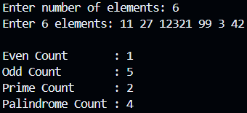

- Conclusion – In this assignment, we’ve implemented program on implementation Of generic collection class vector and performed the logic to count even and odd numbers, prime numbers and palindrome numbers.

